**Data Analysis Report**

**Executive Summary**

Provide a concise overview of the key findings and insights from the data analysis process. **Introduction**

**We have some data that includes:**

* **Id**
* **EmployeeName**
* **JobTitle**
* **BasePay**
* **OvertimePay**
* **OtherPay**
* **Benefits**
* **TotalPay**
* **TotalPayBenefits**
* **Year**
* **Notes**
* **Agency**
* **Status**

**Data Overview**

**Dataset Information**

Number of Rows: [148654]

Number of Columns: [13]

Data Types are represented In Figure 1.

صورة تحتوي على نص, لقطة شاشة, الخط, رقم

تم إنشاء الوصف تلقائياً

Figure [1].

Missing Values: Description of how missing values were handled in Figure 2.

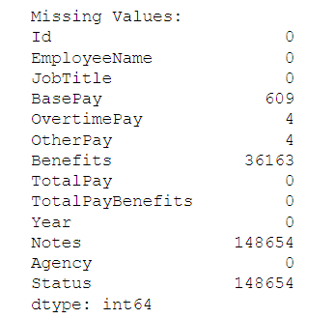

Figure [2].

**Descriptive Statistics**

Mean, Median, Mode of Total Pay, Range of Salaries, and Standard Deviation of Salaries are the results in Figure 3.

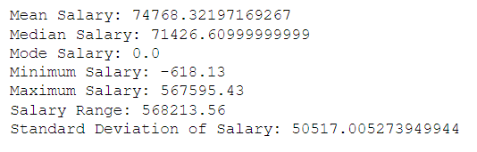

Figure [3].

**Data Cleaning**

Explain the process of handling missing data and any other data cleaning steps performed:

Explanation:

The process begins by loading the dataset from the specified file path.

Missing Values Check:

Subsequently, a thorough examination of missing values in each column is conducted, and the findings are stored in the missing values variable.

Missing Data Handling:

In the case of numerical columns, any missing values are substituted with the mean of their respective columns. For categorical columns, the script utilizes the mode (the most frequent value) to fill in any missing values next figure [4] shows the number of missing values before and after handling.

صورة تحتوي على نص, لقطة شاشة, الخط, رقم

تم إنشاء الوصف تلقائياًصورة تحتوي على نص, لقطة شاشة, الخط, رقم

تم إنشاء الوصف تلقائياً

Figure [4].

**Basic Data Visualization**

**\*Histograms**

Visual representation of the distribution of salaries in Figure 5.

صورة تحتوي على نص, لقطة شاشة, رسم بياني, خط

تم إنشاء الوصف تلقائياً

**Figure [5].**

**\*Pie Chart**

The proportion of employees in different departments is represented in Figure 6.

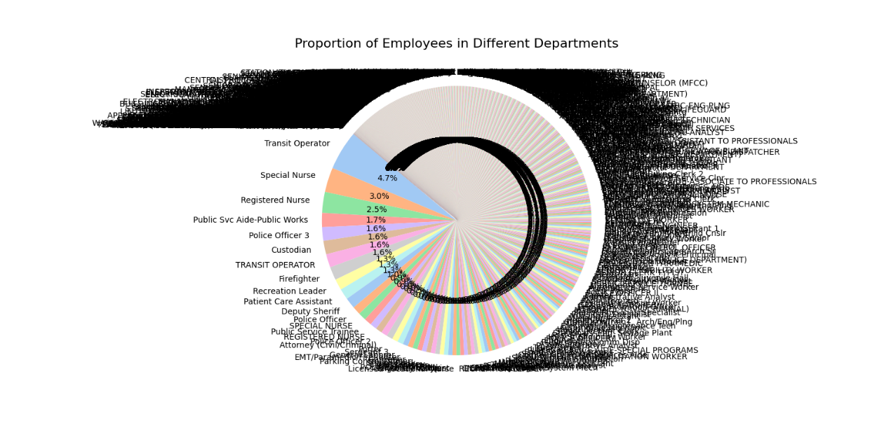

Figure [6].

**Grouped Analysis**

**Grouping by 'Job Title' and 'Year'**

The calculation of average salaries for each group is represented in Figure 7.

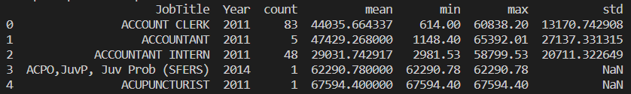

Figure [7].

**Correlation Analysis**

Scatter plot visualizing the relationship between 'Total Pay' and 'Year'.

The correlation coefficient indicates the strength and direction of the relationship it represents in Figure 8.

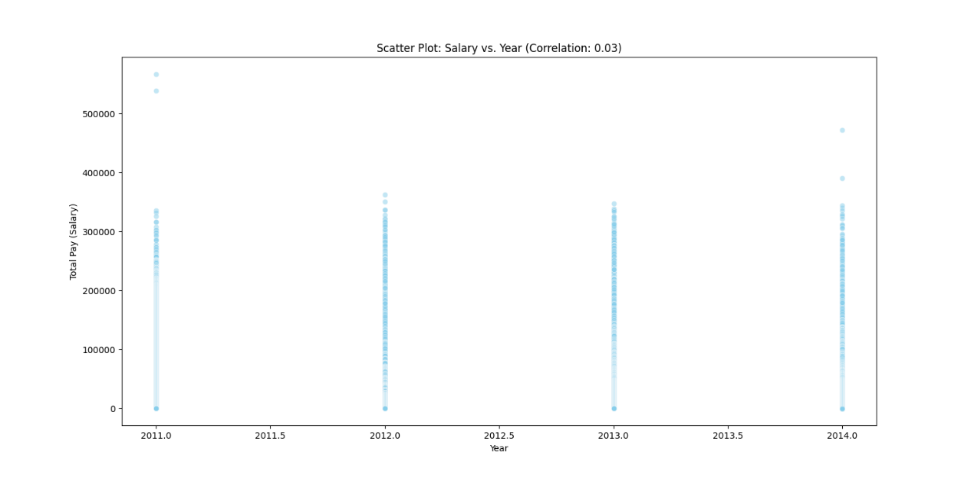

Figure [8].

Certainly! Here's a closing sentence you can use for your data report:

Thank you for exploring the insights derived from data analysis.

Best regards,

[Mohammad Suleiman Abuirsheid]

[moh.abuirsheid@gmail.com]